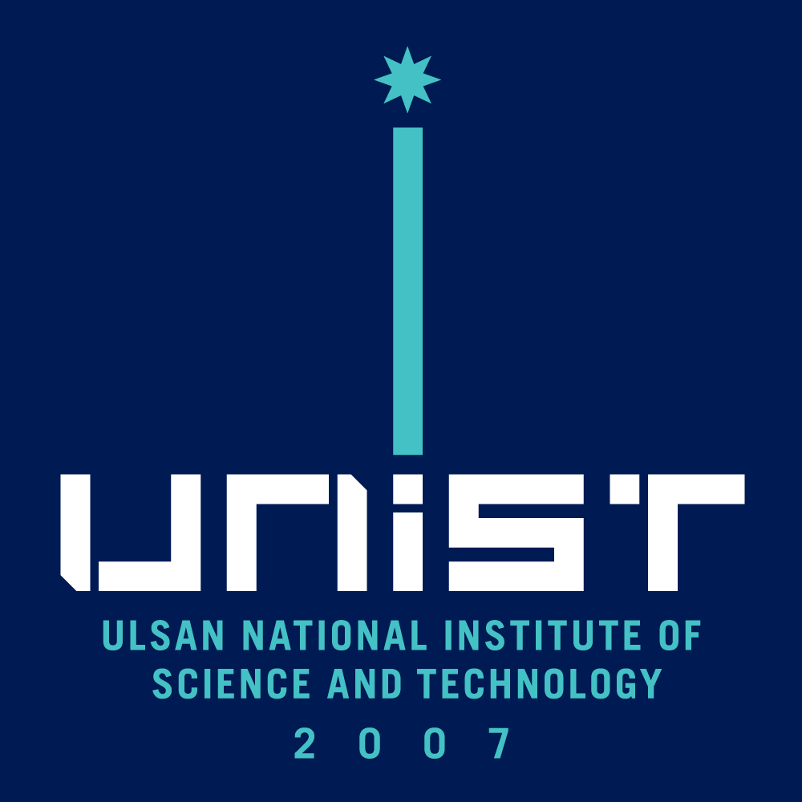 | UNIST GRADUATE PROGRAM  MASTER'S THESIS/DOCTORAL DISSERTATION APPROVAL
THIS FORM MUST BE SUBMITTED WITH THE FINAL VERSION OF THE DEFENDED THESIS/DISSERTATION

DEGREE: □ M.S □ Ph.D

Submitted by: ______________ _______________ Student ID: ___________________________
First Name Last Name

____________________________________________________ in: _____________________________
Degree Name in Full (e.g. Master of Science, Doctor of Philosophy) Name of Program(Major)

Date of Defence: ___________________________________________________________________________
Title:
As advisor for the above student, I certify that I have read the following defended thesis/dissertation, have approved changes required by the final examiners, and recommend it to the Department(School) for acceptance. Furthermore, I the advisor, certify that the aforementioned thesis/ dissertation is the original work done by the student and all referenced work is properly accredited.
Name of Chair Examining Committee (Advisor) |  | Signature of Examining Committee Member |  | Date (yyyy/mm/dd)
The undersigned certify that they recommend this thesis/dissertation to the Graduate School for acceptance and also guarantee that it is the student's original work.
Name of Examining Committee Member |  | Signature of Examining Committee Member |  | Date (yyyy/mm/dd)
Name of Examining Committee Member |  | Signature of Examining Committee Member |  | Date (yyyy/mm/dd)
Name of Examining Committee Member |  | Signature of Examining Committee Member |  | Date (yyyy/mm/dd)
Name of Examining Committee Member |  | Signature of Examining Committee Member |  | Date (yyyy/mm/dd)

NOTE: The signatures of all examining committee members are required for approval.

PROGRAM COMPLETION
 | Student has passed comprehensive exams : |  |  |  |  | □ Yes □ No
 | Student has attained required credits for the degree : |  |  |  |  | □ Yes □ No
Name of Department(School) Head |  |  | Signature of Department(School) Head |  | Date (yyyy/mm/dd)

