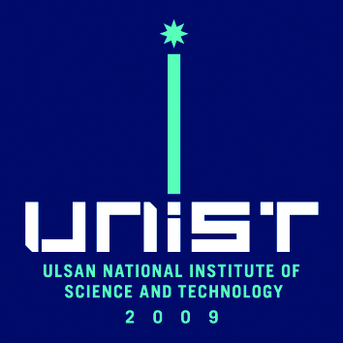

**OFFICE of**

**GENERAL AFFAIRS**

UNIST-Gil 50, Ulju-Gun,

Ulsan, 44919 Korea

Tel: +82-52-217-0114

Fax: +82-52-217-1009

http://www.unist.ac.kr

December 15th, 2014.

Office Work Administrator Gil-dong Hong

Administrative Management Support Bureau

Ulsan City Hall

201, Jungang-ro, Nam-gu, Ulsan, Korea

02-slogon.png

Body Copy